This n That

An e-mail newsletter from Agapé Athletics Club

Editor: Marieta Bortoli 082 466 7031 1 May 2017 www.agape.org.za

E-mail: marietabortoli@gmail.com

NB

- Next league race – Jackie Meklar – 6 May
- Agapé race (Jacaranda City Challenge) – 14 October Members to assist. PLEASE DIARIZE !!!!!!

Editorial

This coming Saturday is a league race. Please remember to complete all relevant information on your entry slip, i.e. name, surname, gender, age and province.

As EXCO we would like to encourage members to wear the correct club clothing. The correct clothing is the Agapé vest and also for the ladies the crop top and a royal blue pants.

Please take note that most of our time trials are starting earlier during winter months. Kindly refer to the starting times under “time trials”

Contents

# Birthday greetings
# Personalia
# Welcome new and former members
# Congratulations
# Thank you’s
# In the mailbox
# General
# Race reports / upcoming race information
# Race results
# Training/Health snippets
# Thought of the week
# Your smile for the week
# Something to ponder over / something spiritual
# AGN league logs
# Races cancelled
# Notice Board
# Photo corner

Notice Board Additions

● The Love Run
Attachments

●

Birthday Greetings
May the Lord bless you and send from above the peace of His presence, the joy of His love. May He grant you happiness in everything you do! Happy birthday!

Marina Stander 01 May | Juline Erasmus 12 May
Judy Ferreira-Prevost 13 May | JP Krause 14 May
Louis Fourie 15 May | Kabelo Letsie 15 May
Vicky Kruger 15 May | Wayne Reinecke 16 May
Dennis Frost 22 May | Rick Sher 23 May
Les Clarke 26 May | Carol de Kiewit 27 May
Charles de Kiewit 27 May | Mavis Stadler 27 May
Pieter Coetzee 28 May | Wilma du Plooy 28 May
Johan Kloppers 29 May

Personalia

Our condolences go to Josias van der Merwe and family for the loss of his mother.

Welcome new and former members

Japie Hugo John Jones

Congratulations

Congratulations to the following members:

Loskop – Ultra 50km
Marius van der Westhuizen who completed his 10th Loskop

Thank you’s

In the mailbox

General

Clothing available:
Buffs @ R100
Ladies skirts @ R200
Second skins @ R170

Please contact Marietjie if you wish to purchase some of the items:
Cell: 072 541 7268 E-mail: ventermarix9@gmail.com

The items will also be available at races, please visit our gazebo

Race reports/Upcoming race information

Loskop 50km Middelburg Saterdag 22 April 2017 – Wallie Weder
Wat ‘n epiese en wonderlike dag. ‘n Miljoen of meer vergader by Wilde Als naby Bloemfontein. Ander kies die makliker pad en doen Loskop - dalk met die regverdiging: “Ons bid 5 of 6 ure”, dis nou afhangende van jou fiksheid om die resies te voltooi!
Ek ry saam met Harry vroeg die oggend en kom betyds in Middelburg voordat die pad gesluit word. Ons gaan haal inskrywingsnommers en kry ook ons T-hemp. Ons rooihemp groepie raak meer tydens die lang wag. Later die spreekwoordelike 8-ape soos oom Jan sou sê. Darem nie so koud nie. Ook lekker om weer vir Gert te sien.

Uiteidelik beweeg ons uit na die wegspring en sukkel dit ‘n bietjie om GPS sein te kry. Ek wag vir die gebruiklike gebed voor die skoot maar dit gebeur nie. Doen toe maar my eie stil gebed: “Lord, let it be for the rest of South Africa to experience so much harmony and unity as it is amongst all races in all races. En waar daar vandag soveel gereis word behoed en bewaar ons hardlopers asook die miljoen of meer mense vandag in Bloemfontein en maak ons pragtige land ‘n veiliger en beter plek”.

Die skoot klap en dit neem ‘n wyle vir almal om aan die gang te kom, op te warm en eie pas te kan handhaaf. Ons verlaat die dorpsgebied deur die pragtige laan bome en die roete begin te klim al die pad tot by die Telkom toring. Die rante is met mis omring en dit voel soos Kaapsehoop.

Afstande is duidelik per km aangedui en waterpunte goed beman, verfrissend en aanmoediged. Ook die rye jong kinders langs die pad dra by met “You can do it!”

Uiteindelik Telkomtoring en dan halfpad. Kranskop laat my aan Jerigo mure dink - troon majestieus bokant ons uit. Dan die eina afdraend en kramp gelykte.

Ek kry vir Rina op 42km. Die einde is in sig. Nog net die laaste “bultjie”.

By ons tent - dis lekker om klaar te wees en almal weer te sien.

Dankie Hennie, geluk Marix en Pierre met 10de en Wayne met eerste Loskop.

Dank ook aan die organiseerders vir ‘n pragtige wedloop, twee medaljes en ‘n sakkie lemoene!

En toe is Loskop 2017 net ‘n herinnering en Wilde Als geskiedenis maar more ‘n uitdaging …of anders gestel “the end of a new beginning.”

Race results
Tshwane - 10km race - 2017-04-29
Position | Initials | Surname | Sex | Age | Finish Time
84 | J | Van Der Merwe | M | 47 | 00:48:22
116 | E | Fourie | F | 50 | 00:50:45
169 | C | Burger | M | 51 | 00:53:52
200 | K | Nurden | M | 82 | 00:55:41
211 | L | Fourie | M | 72 | 00:56:16
258 | J | Benadie | M |  | 00:59:02
317 |  | Cornel | F | 31 | 01:02:05
332 | P | Coetzee | M | 65 | 01:02:41
373 | D | Benadie | F | 50 | 01:05:06
391 | D | Frost | M | 60 | 01:06:02
448 | M | Venter | F | 57 | 01:08:39
449 | H | Venter | M | 57 | 01:08:39
527 | A | Te Reh | M | 67 | 01:12:52
529 | B | Boyes | F | 52 | 01:12:53
531 | S | Bothma | M | 43 | 01:12:56
896 | L | Groenewald | F | 47 | 01:52:02

Tshwane - 10km – walk - 2017-04-29
Position | Initials | Surname | Sex | Age | Finish Time
45 | K | Strauss | F | 73 | 01:30:13
48 | C | Mouton | F | 60 | 01:36:41

Training/Health snippets
Injury Prevention and Massage Therapy
Adequate recovery is essential if a runner is to benefit fully from training and prevent injuries from occurring. One way to hasten this recovery process is by using a regular massage therapy that can assist soft tissue recovery form intense exercise. After exercise, there is a prolonged elevation of muscle tone, felt as tightness, particularly during periods of adaptation to increased volume and intensity of training. This will cause impaired delivery of nutrients and oxygen to the cells and slow down removal of waste products which can contribute to abnormalities. It further limits the extensibility and shock absorbency of soft tissue, thus predisposing to soft tissue strain. Intense training also causes irritation of previously untreated lesions. This causes bulky scar tissue to develop, compromising muscle function and flexibility. This can lead to impaired training and progress to injuries.
The effect of the massage is to reduce excessive post-exercise muscle tone, increase muscle range of motion, increase circulation and nutrition to damaged tissue and deactivate trigger points. It also gives the physiotherapist time to identify any soft tissue abnormalities. It should form part of the warm-down program to maximize recovery for runners who need to exercise regularly. Massages should thus be done more often during peak training. Initially start with once a month and then more often (once a week), depending on the individual. When hill training and speed work forms part of training, massage therapy can be done more often.

Your thought for the week
If you look at the world you will be distressed, if you look within you will be depressed, but if you look at Christ you will be at rest

Your smile for the week
Children Are Quick(er)
TEACHER: Why are you late?
STUDENT: Class started before I got here
--------------------------------------------------------
TEACHER: Maria, go to the map and find North America
MARIA: Here it is
TEACHER: Correct. Now class, who discovered America?
CLASS: Maria
--------------------------------------------------------
TEACHER: John, why are you doing your math multiplication on the floor?
JOHN: You told me to do it without using tables
--------------------------------------------------------
TEACHER: Glenn, how do you spell 'crocodile?'
GLENN: K-R-O-K-O-D-I-A-L'
TEACHER: No, that's wrong
GLENN: Maybe it is wrong, but you asked me how I spell it.
-------------------------------------------------------
TEACHER: Donald, what is the chemical formula for water?
DONALD: H I J K L M N O
TEACHER: What are you talking about?
DONALD: Yesterday you said it's H to O
-------------------------------------------------------
TEACHER: Winnie, name one important thing we have today that we didn't have ten years ago
WINNIE: Me!
------------------------------------------------------
TEACHER: Millie, give me a sentence starting with 'I'
MILLIE: I is…
TEACHER: No, Millie...... Always say, 'I am.'
MILLIE: All right... 'I am the ninth letter of the alphabet'
------------------------------------------------------
TEACHER: Now, Simon, tell me frankly, do you say prayers before eating?
SIMON: No sir, I don't have to, my Mom is a good cook

Something to ponder over / something spiritual

LET IT GO [T. D. Jakes]
There are people who can walk away from you. And hear me when I tell you this!... When people can walk away from you: let them walk.
I don't want you to try to talk another person into staying with you, loving you, calling you, caring about you, coming to see you, staying attached to you. I mean hang up the phone. When people can walk away from you let them walk. Your destiny is never tied to anybody that left.
The Bible said that, they came out from us that it might be made manifest that they were not for us. For had they been of us, no doubt they would have continued with us. [1 John 2:19]
People leave you because they are not joined to you. And if they are not joined to you, you can't make them stay. Let them go. And it doesn't mean that they are a bad person it just means that their part in the story is over. And you've got to know when people's part in your story is over so that you don't keep trying to raise the dead. You've got to know when it's dead. You've got to know when it's over. Let me tell you something. I've got the gift of good-bye. It's the tenth spiritual gift, I believe in good-bye. It's not that I'm hateful, it's that I'm faithful, and I know whatever God means for me to have He'll give it to me. And if it takes too much sweat I don't need it. Stop begging people to stay. Let them go!!

If you are holding on to something that doesn't belong to you and was never intended for your life, then you need to LET IT GO!!! If you are holding on to past hurts and pains ...LET IT GO!!! If someone can't treat you right, love you back, and see your worth...LET IT GO!!!
If someone has angered you ... LET IT GO!!!
If you are holding on to some thoughts of evil and revenge LET IT GO!!! If you are involved in a wrong relationship or addiction ... LET IT GO!!! If you are holding on to a job that no longer meets your needs or talents ... LET IT GO!!!
If you have a bad attitude...LET IT GO!!!
If you keep judging others to make yourself feel better... LET IT GO!!! If you're stuck in the past and God is trying to take you to a new level in Him...LET IT GO!! If you are struggling with the healing of a broken relationship....LET IT GO! If you keep trying to help someone who won't even try to help themselves... LET IT GO! If you're feeling depressed and stressed .... LET IT GO!!! If there is a particular situation that you are so used to handling yourself and God is saying "take your hands off of it," then you need to... LET IT GO!!! Let the past be the past. Forget the former things. GOD is doing a new thing for you LET IT GO!!! Get Right or Get Left .. think about it, and then LET IT GO!!!

"The Battle is the Lord's!"

League results

Cancelled Races

The Green Mile AC has cancelled their race that was scheduled for Friday, 16 June (public holiday).

Notice Board

Useful Links:
www.raceresults.co.za/flyers - for the latest race pamphlets
www.agn.co.za/#League for the latest league logs and the league points you earned
http://www.agn.co.za/Docs/2016/WAlking/AGN%20road%20walking%20stds%20ref%20685.pdf
AGN 2016 RW qualifying standards and selection criteria
www.runawaysport.co.za Run-A-Way Sport’s web site
www.verticalhorison.co.za Trail Running www.trailseries.co.za Trail Running
http://www.mastersathletics.net/Age-Graded-Calculator.2595.0.html Age Graded Calculator
http://www.sportsinjuryclinic.net/symptom-checker By clicking where it hurts then ticking which symptoms most apply to you we can give you an indication of what injuries may apply.

League Race
Saturday 6 May Jackie Meklar Race 25/10/5 km run/walk
Race Organisers: PMMC
Venue: Pretoria Military Sports ground, Thaba Tshwane (Voortrekkerhoogte)
GPS: S25 47’15.35” E28 8’20.22”

 | 25 km | 10 km | 5 km
Entry-fee | R 90 | R 70 | R 30
60+ | R 40 | R 30 | Free
70+ | Free (no t-shirt)
Start Time | 06:30 |  | 06:45
Cut-off | 04:00 | 02:30 | 01:30

Free t-shirts to the 1st 1 200 online entries

No wheelchair athletes or prams will be allowed due to traffic conditions

Pre-entries at: Run-away Sport; The Runners Store Tramshed; Running Inn; Sweatshop Dunkeld West, Southdowns; Sportmans Warehouse Princess Crossing, Montana Crossing

www.entrytime.com

Saturday 13 May The Love Run 21.1/10/5 km
Race Organisers: Love Running
Venue: Hatfield Christian Church, c/o January Masilele Drive & Garsfontein Road, Menlyn, Pretoria East

 | 21.1 km | 10 km | 5 km
Pre entry-fee | R 90 | R 70 | R 50
Race day entry-fee | R 100 | R 80 | R 50
Entry-fee 70+ | Free
Start Time | Walkers 06:45  Runners 07:00 |  | 07:20
Cut-off | ??:00

Pre-entries at: Run-away Sports; Sweatshop Southdowns; Audi Centre – Arcadia & Menlyn; McCarthy Volkswagen – Wonderboom, Arcadia,Menlyn & Silver Oaks

Saturday 20 May Race of Hope 21.1/10/5 km
Race Organisers: Run/Walk for Life
Venue: The Grove Mall, c/o Lynnwood & Simon Vermooten Rd, Equestria, Pretoria

 | 21.1 km | 10 km | 5 km
Entry-fee | R 80 | R 70 | R 40
Start Time | 07:00
Cut-off | ??:00

Pre-entries at: Total Sports – The Grove Mall

www.enteronline.co.za

Saturday 27 May Superspar Hercules Skosana Legend 10/5 km run/walk
Race Organisers: Run/Walk for Life
Venue: Superspar, Moort Street, Hercules, Pretoria

 | 10 km | 5 km
Entry-fee | R 60 | R 40
Start Time | 07:00
Cut-off | ??:00

Pre-entries at: Run-away Sport; The Runners Store Tramshed; Hercules Superspar

www.enteronline.co.za

2017 AGN LEAGUE FIXTURE LIST
EVENT | DISTANCE | DATE | LEAGUE
 |  |  | RR | RW
Jackie Meklar | 10 / 25 km | 06/05/17 | X | X
Run/Walk for Bibles | 10 / 21.1 km | 24/06/17 | X | X
Long Walk/Run for Freedom | 10 / 21.1 km | 22/07/17 | X | X
Marcel van’t Slot | 15 km | 19/08/17 | X | X
Addicted to Life | 10 / 21.1 km | 09/09/17 | X | X
Jacaranda Challenge | 10 / 21.1 / 42.2 km | 14/10/17 | X | X
Kolonnade Retail Park | 10 / 21.1 km | 11/11/17 | X | X

Masters Athletics Fixture list

Local meetings
12 August 2017 Claude Sterley memorial masters meeting Pilditch
? Sept/? October 2017 SWD Oudtshoorn
11 November 2017 Free State Bloemfontein

African Masters Track & Field Championship
27 – 29 May 2017 Cameroon

SA Masters Championships
4, 5 & 6 May 2017 SA’s WP – Groenpunt stadion

Time Trials:

Centurion -
Lewende Woord Centurion on Wednesdays at 17:15
Contact Marinda 654 5800 (h) 082 720 9017

Rietondale –
North Street, Rietondale (Rietondale Park in the street before the Crawford Stadium) Thursdays 17:30
Contact Dorothy Benadie 082 704 2300 dorothy.benadie@gmail.com or
Hennie Venter 083 702 4472

Zita Park - Tuesdays at 17:30
Zita Street, Zita Park, Garsfontein
Contact Hennie Venter – 083 702 4472 Marietjie Venter – 072 541 7268

Gazebo Enquiries

Hennie Venter – 083 702 4472 Marietjie Venter – 072 541 7268

Intercessor:

Fred Harding 076 777 7786 

Agapé Executive 2016/2017

Name | Position | Telephone number | E-mail address
Marieta Bortoli | Chairperson & editor | 012 331 2089  082 466 7031 | marietabortoli@gmail.com
Hennie Venter | Registrar & club captain | 083 702 4472 | henniev@seng.co.za  join@agape.org.za
Marilett Jenkins | Secretary | 082 837 2142 | marilett.jenkins@mervitzmalan.co.za
André Breytenbach | Treasurer | 083 566 1090 | andreb@geoscience.org.za
De Wet de Beer | PRO & vice-chairman | 082 373 2987 | dewet@styletechnique.co.za
Kobus Stander | Race organiser | 082 688 6697 | CLK1560PHARM@clicks.co.za
Fred Harding | Intercessor | 076 777 7786 | fredharding@telkomsa.net
Marietjie Venter | General activities & clothing co-ordinator | 072 541 7268 | Ventermarix9@gmail.com
Gustav Brink | Statistician | 083 417 8431 | gustav.brink@gmail.com

Photo corner

Agapé Executive

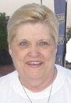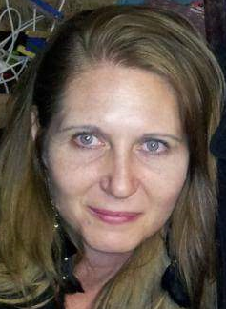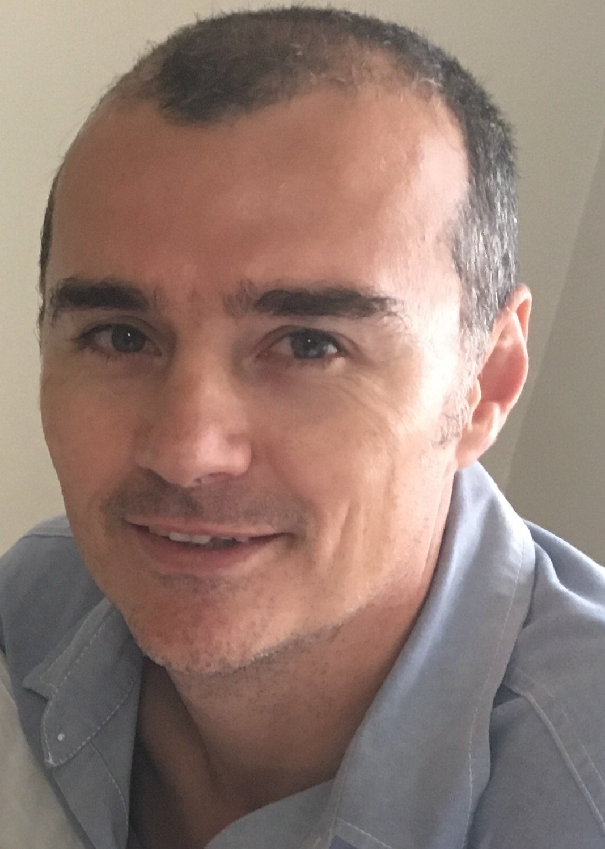

Marieta Bortoli Marilett Jenkins De Wet de Beer

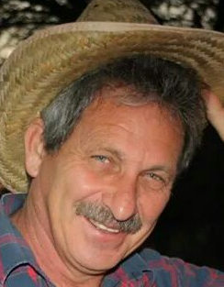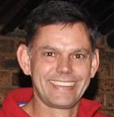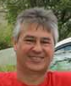
Hennie Venter André Breytenbach Kobus Stander

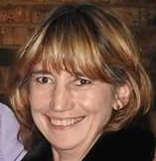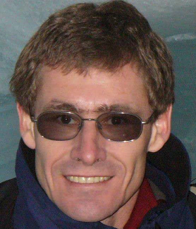
Marix Venter Fred Harding Gustav Brink (Ex-officio)

Photo taken at Loskop race
